Govt. high school
Sindhi Jamaat Co-Operative Housing Society, Karachi
Final Term Examination 2024-25
Paper: English | Class: Three | Total Marks: 100
Name: ___________________ |  | Date: ____________

{Section “A”}
Q1: Multiple Choice Questions:
1- What is the plural of child?
a) Child
b) Children
c) Childrens
2- Choose the opposite of big.
a) Small
b) Tall
c) Large
3- Identify the correct spelling.
a) Rainbwo
b) Rainbow
c) Rianbow
*Word Association.
4- Which word is related to school?
a) Doctor
b) Teacher
c) Pilot
5- What is the masculine of lion?
a) Lioness
b) Mare
c) Tigress
Q2: fill in the blanks.
- The sun __________ in the east.
- I saw _______ elephant in the zoo.
- She _________ a song beautifully.
- The meaning of word solo is _________
- They _________with the balloon.
Q3: match the following.
COLUMN A | COLUMN B
Birds | Blows
Fish | Shines
The wind | Fly
The sun | Swim
A dog | Barks

- Three in a row:
In each puzzle, find three words are the same family.
Mango | carrot | Juice
chips | apple | Candy
arm | lollipop | Banana
button | class | Spring
socks | winter | Food
summer | toys | book

Q5: make new words by rearranging the letters of the underlined words:
- Change meat into group of players. __________
- Change eats into a hot drink. _______
- Change pat into something from which you can get water. _____
- Change shore into an animal you can ride ______
- Change earth into the most important organ in your body. _____
Q6: complete the following words.
1) _ _ change
2) Fes_ _ Val
3) H_ r_
4) Ce_ _ brate
5) D_co_ _ te
6) G_ _ _ ting
Q7: write the meaning of given words.
Words | Meaning
Festival
Brave
Decorate
Solo
year

Q8: write the past tense of given words.
Present tense | Past tense
Dance
Scold
Look
Laugh

{Section “B”}
Q9: Read the letter of invitation in the box below:
Dear Sana, House No.25,
High street Karachi.
5th August 2017.
Please come to an Eid party at my house on 10th august. It will be from 4o’ clock to 6o’ clock.
It will be very if you can come.
Your Friend,
Sana
Answer the following questions. {4}
- Who wrote this letter?
A-
- Why did she write this letter?
A-
- Where is the party going to be?
A-
- At what time it will start?
A-
- At what time it will end?
A-
Q10: Answer the questions.
- who is the youngest hero of Pakistan?
A-
- How do Pakistanis do greet on Eid festival?
A-
- When do Christians celebrate Christmas?
A-
{Section “C”}
Creative Writing.
Write short paragraph. {5-6}
“My best friend”
OR
“My daily routine”

Picture composition.
Write 3-4 sentences about given picture. {any one}
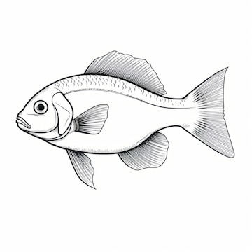

1-
2-
3-
4-

1-
2-
3-
4-

